CERDEC GUI User Manual

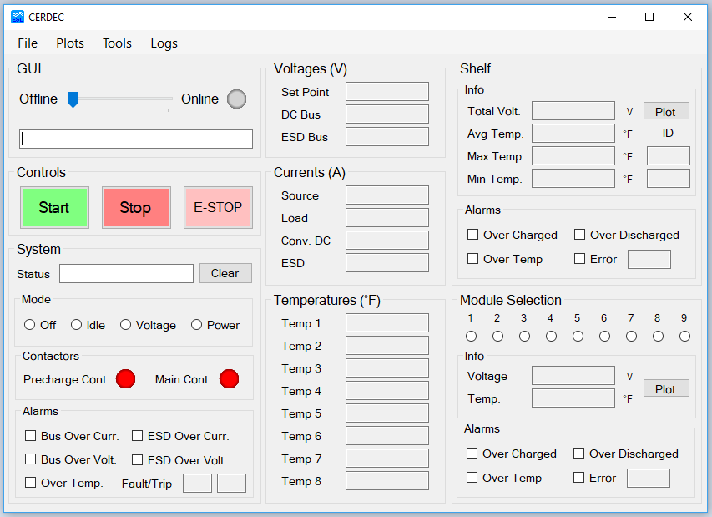

**Overview**

The main purpose of this software is to monitor the operations of the CERDEC Energy System. It displays live readings received from ESL’s Energy Storage Device (ESD) and PCKA’s Converter, as well as offer ways of controlling the mode of the converter. This GUI connects to the ESD via a USB A-A cable and initiates a data fetch protocol with a 50msec sampling period (20Hz). The GUI screen is updated after each period. After initiating the data fetch, if more than 5 sequential data packets are not detected, the GUI moves to a disconnected to state.

Connecting to the ESD

1. Connect the computer to the ESD using a USB A-A cable.
   1. Use the bottom USB port of ESD
2. Open Device Manager and note any new COM Ports – Use this to connect to in the GUI
   1. If none are noted, plug the cable into the computer again and wait for the list to refresh
3. Open the GUI software by double clicking the “cerdec_gui.exe” icon
4. Move the slider in the GUI section from Offline to Online
   1. If no saved COM ports are detected, select yours from the dropdown list

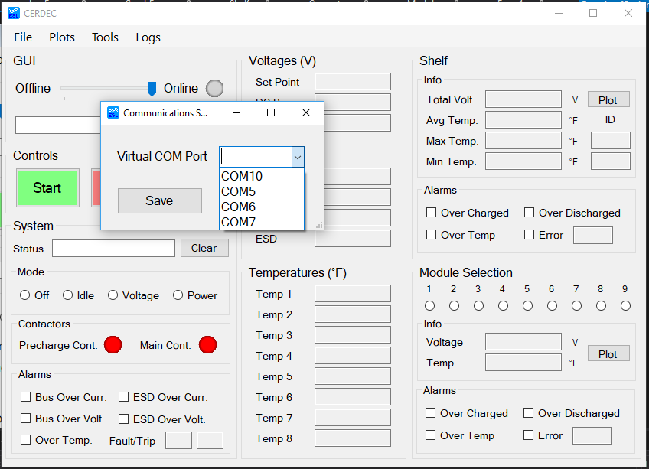

1. The Communications LED will blink green when the GUI is connected to the ESD

**Sections Overview**

GUI

LED and trackbar show status of the GUI to ESD connection. The text box displays statuses to the user from the GUI and allows for logging entries into the User Log.

Controls

Allows for the user to Start or Stop the system. E-Stop button initiates an emergency stop (waiting for further details).

System

Shows the status of the System as reported by the PCKA Converter or the ESD.

The Mode radio buttons allow the user to select what mode they wish the system to operate in (waiting for further details).

The Contactor LEDs show the status of each contactor in the system. Red is Open. Green is Closed.

Alarms as reported by the PCKA Converter are reported using checkboxes. If a checkbox is checked, then that alarm status has been triggered. The Fault and Trip codes are shown in their respective fields.

Voltages

Shows all the voltage readings concerning the Converter. All readings are in volts.

Currents

Shows all the current readings concerning the Converter. All readings are in amperes.

Temperatures

Shows all the temperature readings concerning the Converter. All readings are in Fahrenheit.

Shelf

Info panel displays the total voltage of all the capacitor modules, the average temperature of a module, the maximum/minimum temperatures of the modules, and the IDs of the respective max/min temperature modules. The readings are retrieved by the ESD from the Ultimo Master Controller for the super capacitors.

The Plot Button plots the last 30 seconds of recorded data. Multiple plot windows can be opened at once.

All alarms and Errors are displayed as checked checkboxes. The reported Error Code is displayed, and if the Error Code is anything other than 0x00, double-clicking the text box will display the error’s message.

Module Selection

The user can choose which module’s information to display by selecting the appropriate radio button. This will change the Current Module (and reset the Current Module Data Record).

The Current Module’s voltage and temperature, as reported by the Ultimo Master Controller, are displayed in their respective fields.

The Plot Button plots the last 30 seconds of recorded data. Multiple plot windows can be opened at once.

All alarms and Errors are displayed as checked checkboxes and the Error Code is displayed.

**Toolbar Menu Overview**

File

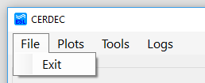

Exit – Another way to exit the program. No different than the “red X” button.

Plots

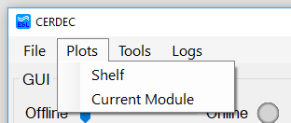

See data plots for each displayed option.

Tools

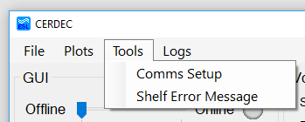

Comms Setup - Allows for the user to manually select a new COM Port.

Shelf Error Message - Displays the current error message for the shelf. Another option than double-clicking the text field.

Logs

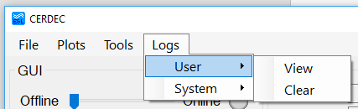

The User Log option allows the user to view their self-entered log messages, or clear them from their “Terminal,” so to speak.

The System Log option allows the user to view system’s logged messages, or clear them from the “Terminal,” so to speak.

**Plots Overview**

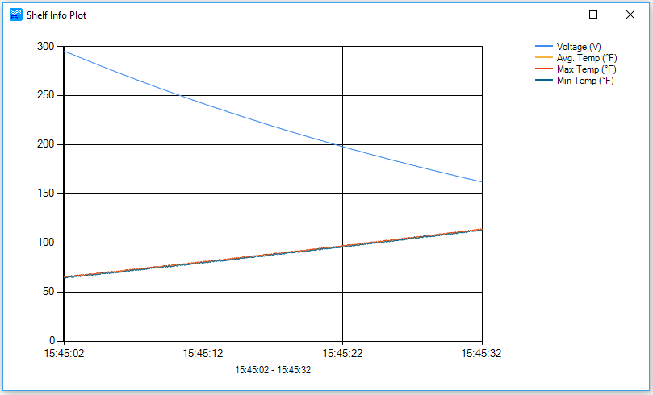

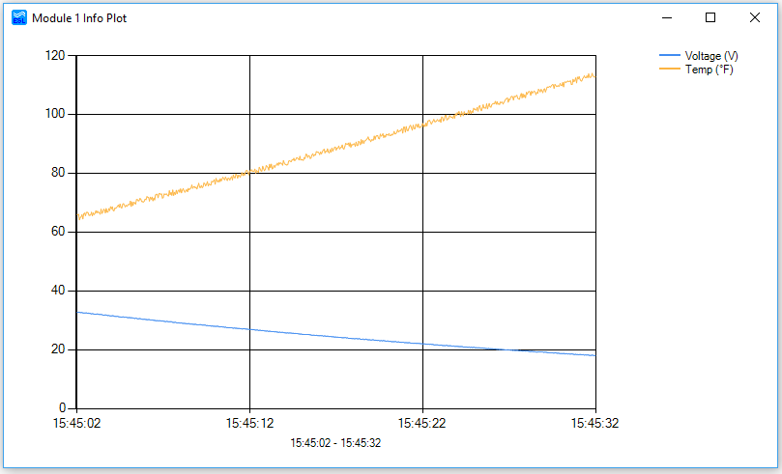

Features

Shows data for the past 30 seconds of recorded data using a moving buffer.

Can have multiple windows of the same “component” open showing different time windows.

Color coded legend in upper right.

X-Axis is 24-hour time format.

Zoomable via Click and Drag.

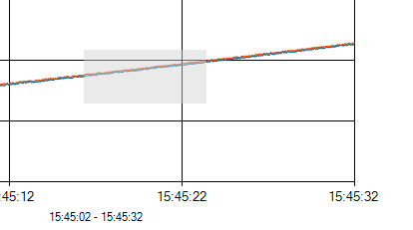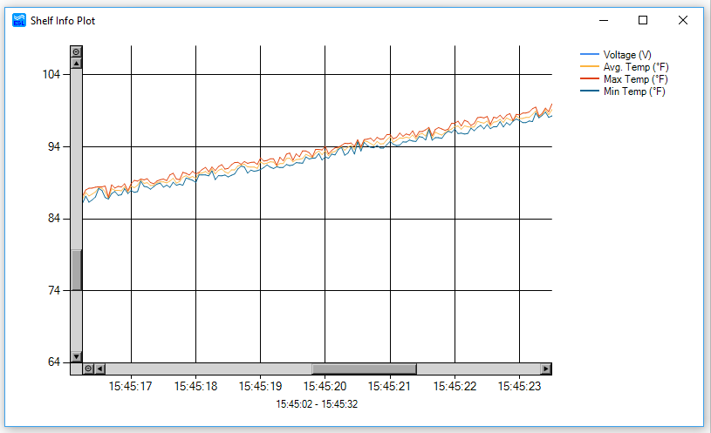

Resizable window via Click and Drag.

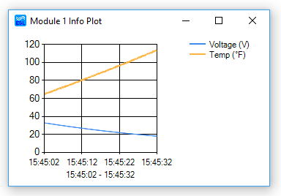

Double-clicking on a point shows which series it belongs to, time of occurrence, and value.

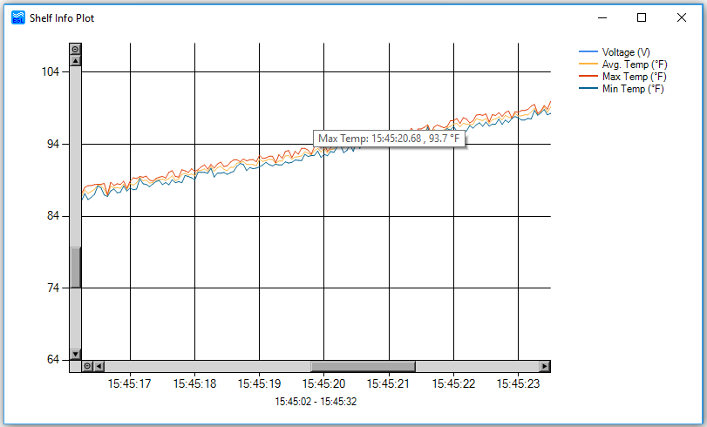

**Log Overview**

User Log

The User Log is a way for the user to quickly write a note to themselves.

To save a log, enter text into the GUI section text box and hit the “enter” key. A message saying “new user log entry” will fill in the text box confirming the entry. Each message is automatically time stamped in 24-hour format.

Currently a 1000 entry limit.

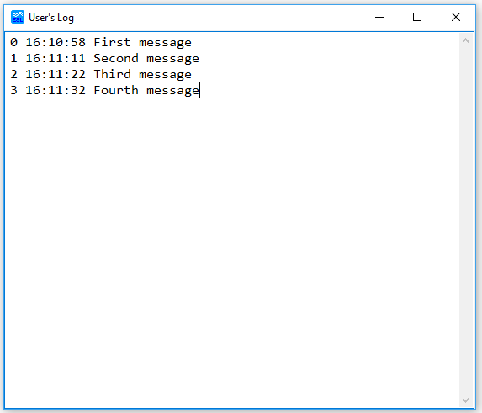

System Log

The System Log is a way for the developer to easily output logs of the system and software as they operate without having to be in a developer environment. Each message is automatically time stamped in 24-hour format.